User Guide 13 What can the public do in SPEAR?
Purpose of this User Guide
The purpose of this User Guide is to provide assistance to members of the public and registered SPEAR users about what functions are available to the public in the SPEAR system.
Who should read this?
Primary audience: All SPEAR users and members of the public including property owners, solicitors, banks, developers, and any others interested parties.
Introduction
There are three key functions available to members of the public from SPEAR:
- View an Application List / application overview (no registration required).
- View details of an application for applications that are under advertisement (no registration required).
- Lodge/withdraw an objection (after registering as an objector).

13.1 Can a member of the public view a list of SPEAR applications?
Members of the public can search and view a list of applications, including the application status, at any time using the ‘Public Search’ function on the SPEAR website. This can be accessed by clicking ‘Search current SPEAR applications’ on the SPEAR homepage: www.spear.land.vic.gov.au/spear/

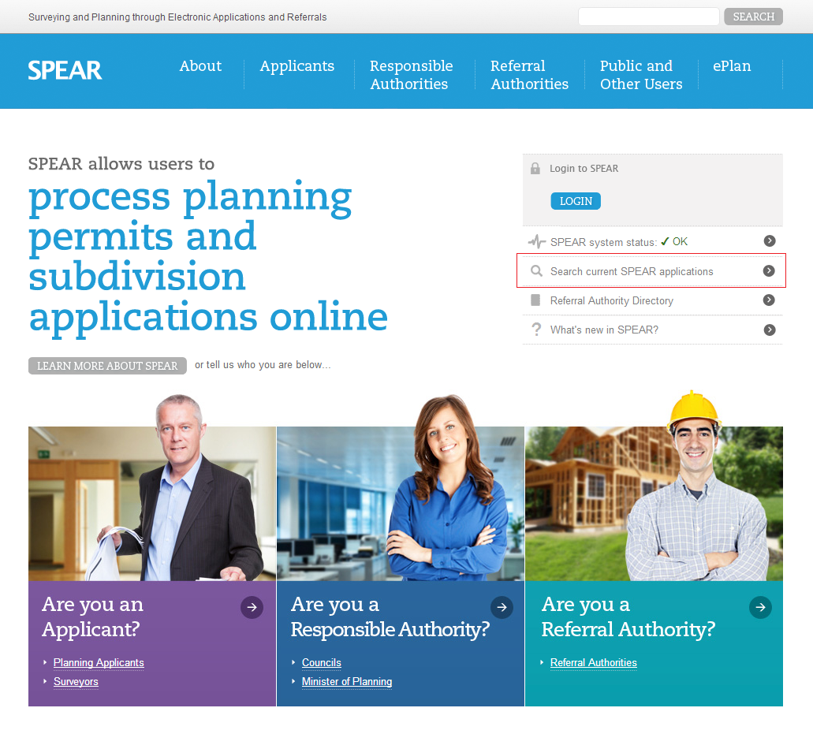

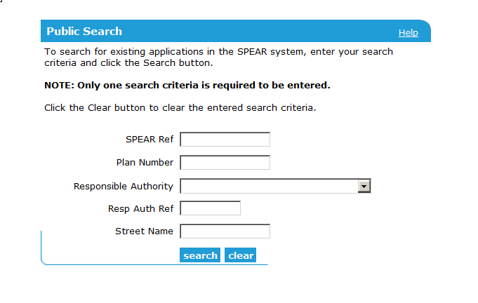

The following screen represents an example of the returned results.
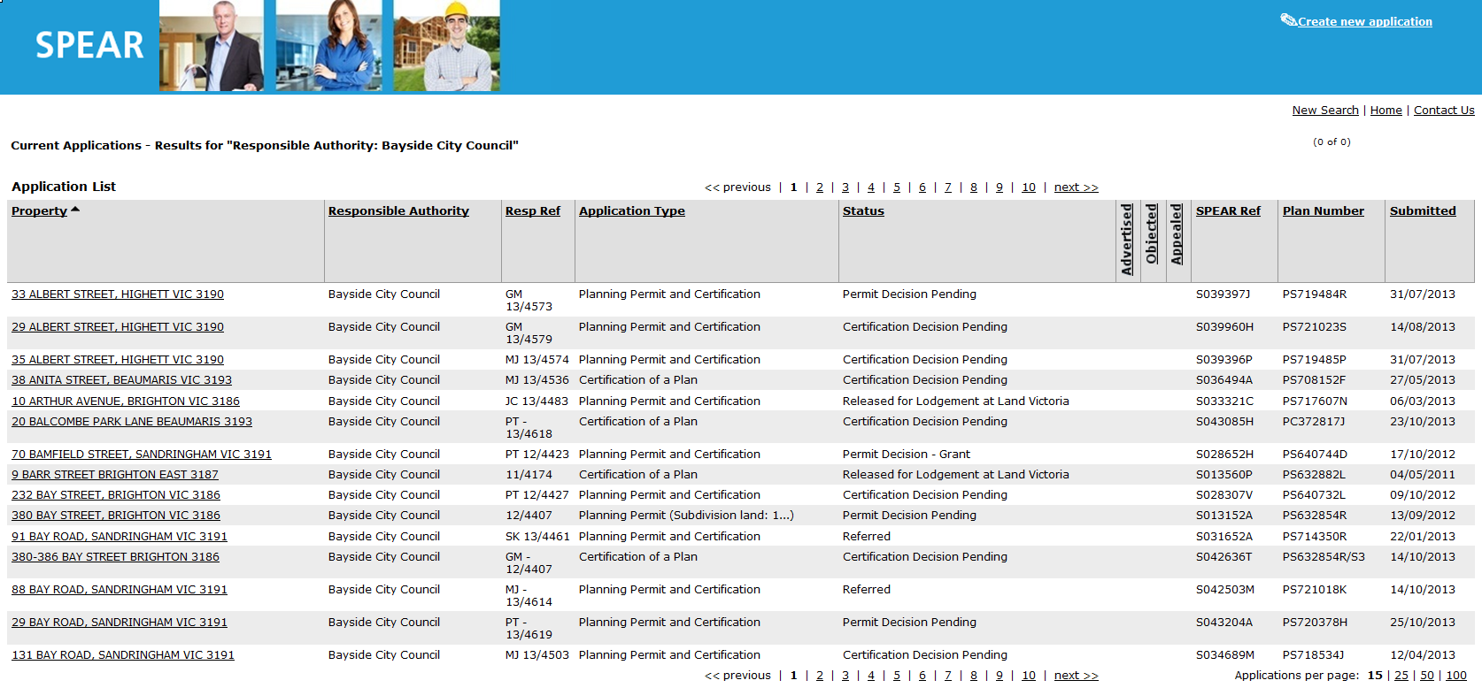

13.2 How do members of the public view details of applications in SPEAR?
Any application in SPEAR can be viewed in a public search, without having to obtain a user name or password in SPEAR.
The type of application (and its processing state) will determine the level of information available through the Public Search screen.
To view an application in more detail, including the nominated property, the nature of the proposal and the name of the Applicant Contact, click the hyperlinked property name for that application.
If an application is under advertisement, certain key documents supporting the application may also be viewed by the public under the Documents heading as shown below. These documents can be viewed / printed as required.
You will also notice that the phrase ‘Advertised’ is displayed in red font within the Milestones section.

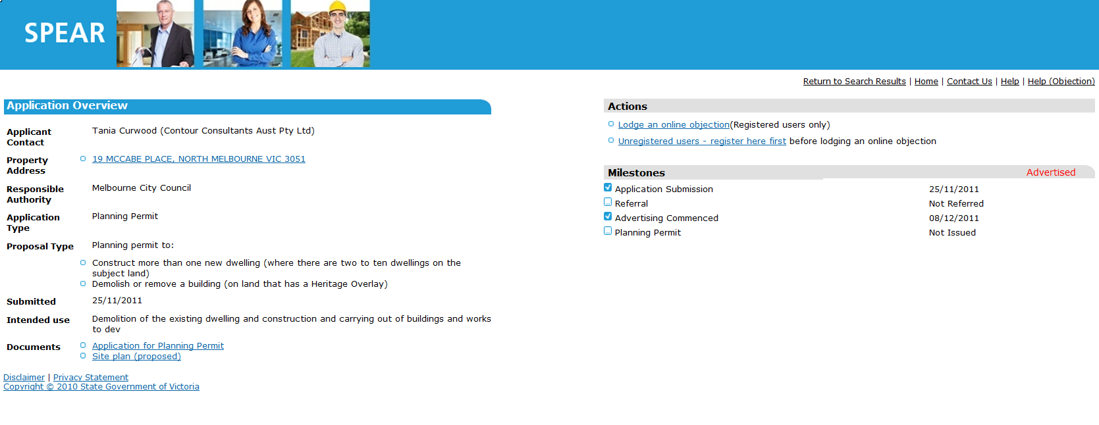

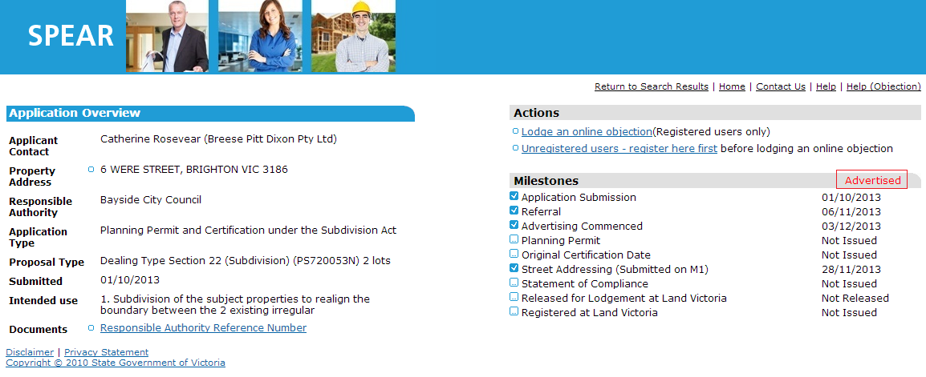

The documents will remain accessible to the public until the Responsible Authority makes a planning permit decision (for planning permit applications) or the plan of subdivision has been registered at Land Use Victoria.
If the application is being advertised outside of SPEAR, the milestone will show ‘Advertised: Outside of SPEAR’, and no documents will be available via the Public Search.
Application documents can also be accessed directly from the Responsible Authority’s office in accordance with their existing process for people that do not have access to the Internet.
13.3 How do you lodge an online objection in SPEAR?
Objectors must register in SPEAR before they can lodge an objection to an application.
Each registered objector can object to only one SPEAR application at a time.
Objectors can register by clicking on the register here first link on the SPEAR homepage (in the registered user’s box), or on the Summary tab of an advertised application.
Once agreeing to terms and conditions, the objector completes the online registration form, and selects the tick box to indicate they are registering as an objector.
SPEAR will automatically email them a username and password to their nominated email address.
The objector can now login to SPEAR from the SPEAR homepage. The first time a user logs in to SPEAR, they are prompted to change their password. See the SPEAR Password Rules at the bottom of this document for more details.
The objector can then proceed to search for the application they wish to object to, and click the underlined address details of the property to view the Summary tab.
NOTE: Objections can only be made through SPEAR to applications that have been advertised in SPEAR. If the application is advertised outside of SPEAR, then the objection must be lodged directly with the Responsible Authority.
To lodge the objection, the objector can click the Lodge an online objection link in the ‘Actions’ section of the screen.
The objector is then prompted to add their letter of objection. The letter should include the objectors name, address and telephone number.
The objection letter can be attached to SPEAR, provided it is in PDF format. Alternatively, the objector can type (or copy & paste) the required text into the text box provided (as shown below).
The objector must tick the tick box to indicate that they understand that the objection may be viewed by other interested parties and then click ‘lodge objection’ to finish.
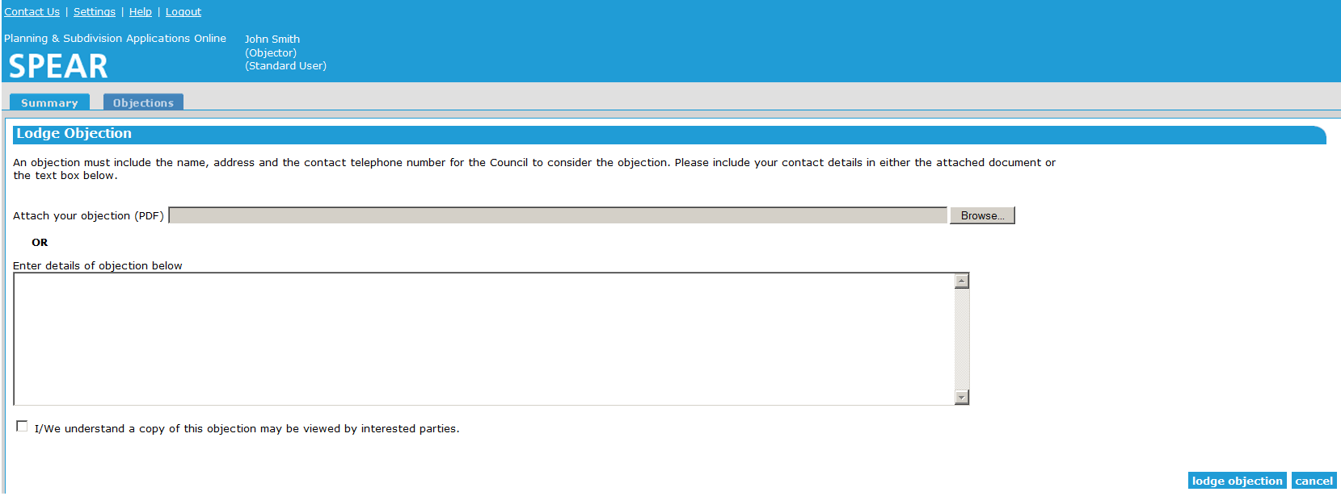

Other objections in the application can be viewed by clicking the View other people’s online objections link on the Summary tab.
The Responsible Authority and Applicant Contact will receive an email notification advising them of the new objection.
13.4 How do objectors withdraw an objection from SPEAR?
This may prompt either the Responsible Authority or Applicant Contact to correspond with the objector and negotiate changes to resolve objections.
Following discussions and/or alterations to the application, the objector may wish to withdraw or re-submit their objection. Access these options by logging into SPEAR, searching for the property, and viewing the application details on the Summary tab.
To make alterations to the objection, the objector must withdraw their current objection. They will then have the option to ‘Lodge an online objection’ which will allow them to add their new/amended letter of objection to the application.
The Responsible Authority and Applicant Contact will receive notifications from SPEAR advising of the changes.
13.5 Password Rules
The following rules apply when creating your new SPEAR password.
- Minimum length of 8 characters.
- Must contain at least one upper case letter (A-Z), one lower case letter (a-z), and one digit (0-9).
- Must not contain more than four identical consecutive characters.
- Must not contain the user's login ID.
- Must not be the same as any of the last 12 passwords for that user.
- Must not have any more than five consecutive characters in common with the previous password.
- Any keyboard symbols are allowed, but not required in passwords. They include - ` ! @ # $ % ^ & * ( ) _ + { } [ ] | \ : ; " ' < , > . ? / .
If you wish to change your password prior to expiry, ensure that you are logged into SPEAR first and then select the Settings hyperlink.

Need more information?
Further information on this topic can be found by:
- Visiting the SPEAR website www.spear.land.vic.gov.au/SPEAR
- Contacting the SPEAR Service Desk on 9194 0612 or email spear.info@delwp.vic.gov.au
- Selecting the Help link in the relevant area of the system.

